Discover Sahaja Yoga Meditation
Through Windham/Raymond Adult Education

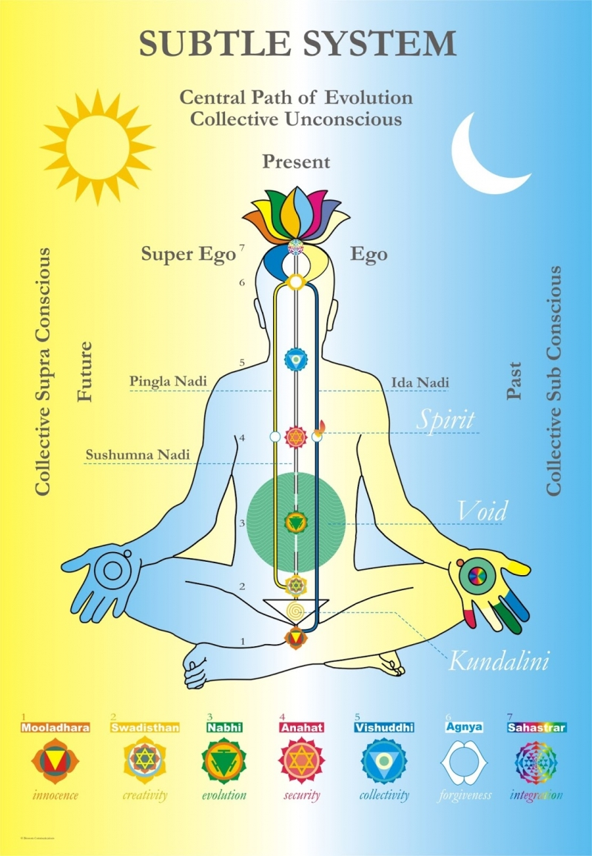

Register
https://windham.coursestorm.com/course/sahaja-yoga-meditation2?search=sahaja+yoga

Sahaja Yoga is a unique method of meditation developed by H.H. Shri Mataji Nirmala Devi and based on an experience called Self Realization that can occur within each human being. Through this process an inner transformation takes place by which one becomes balanced and integrated mentally, emotionally, physically, and spiritually. Like the sprouting of a seed it is a natural, living experience. Sahaja means “born with” and yoga means “union” or “connection.” Sahaja Yoga does not require physical exercise and no previous experience is necessary. Jerry Mayfield has shared Sahaja Yoga for nearly 20 years in universities, libraries, prisons, drug and alcohol rehab facilities, community centers, street fairs, and even in a mid-town Manhattan elevator stuck between floors. He teaches voluntarily for Adult Education. A $9 facilities fee supports Adult Ed programs.
Apr
Apr 4 - May 2nd, 2017 (No class 4/18)
Tue for 4 weeks from 6:15 - 7:30 pm

